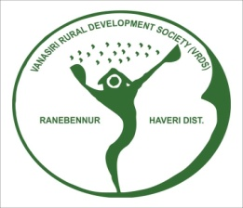

ANNUAL REPORT - 2022-23

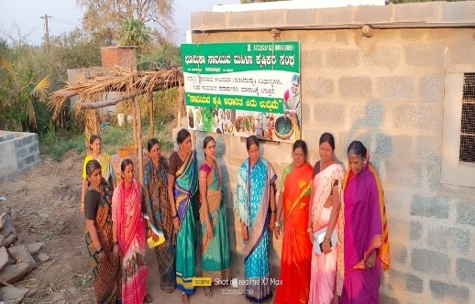
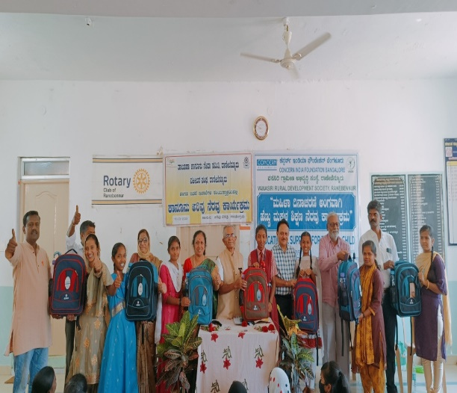
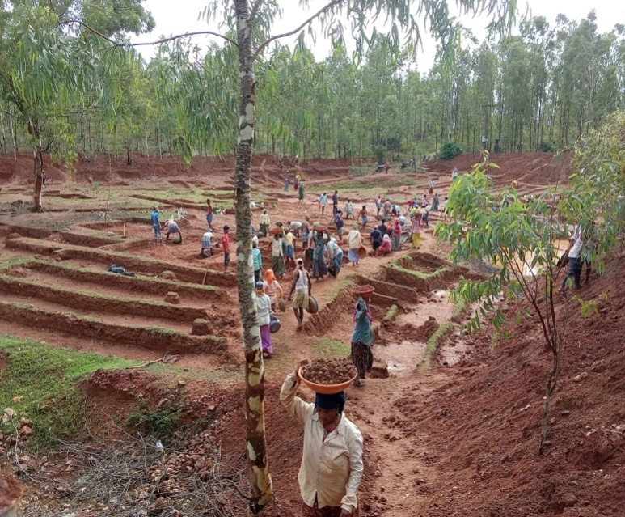
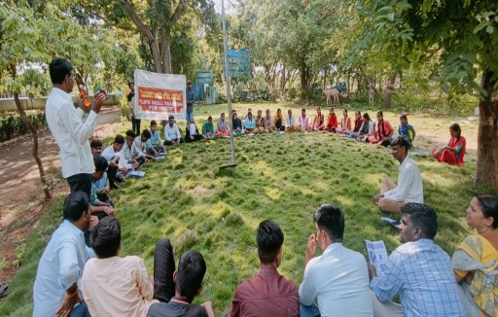

Vanasiri Rural Development Society
Ranebennur, Haveri, Karnataka
e-mail: vrdsrnr@gmail.com Mobile : 7619128602

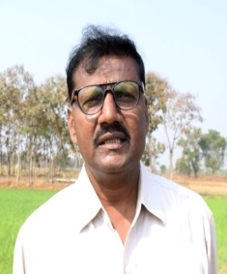

From Executive Director Desk

Dear Sir/Madam,

We are pleased to present the Annual Report of Vanasiri Rural Development society (VRDS) for the year 2022-23. VRDS completed now 19 years development journey. We proud to share the progress, learning’s and impact of the 2022-23. We initiated variety of activities for the development of local organisation and bring sustainable livelihood support ecosystem. Community based institutions like Labor Bank Union, Bhoomika Farmers Producer Organization (FPO), Kantesh Farmers Producer Company limited (FPCL) are empowered and continued on its own strength.
VRDS initiated the Formation and strengthening of District MGNRES Labour Union and Labour Bank a innovative concept getting deep root and brought attention of the State. Natural Resource rejuvenation and management taken up successfully through Watershed, Agriculture and MGNREGS programme. Children Education, Child girl projects brought smile and brightness on their future at urban slum and village children. Skill development, linkages with financial institute, resource mapping for better Livelihood activities carried by women self help groups, marginal farmers and landless community. Our innovative projects drawn attention of the media, government and donor agencies it needs to be expand. We brought multiple stake holders together in the process of Food Security, Health and Nutrition programs.
VRDS developed linkages with network at taluk and district level. Further linkages developed similar kind organizations active at across the District/State. We also established linkages with National and International organisations. Common issues, policy matter, lobby and advocacy were taken at different level.
We ensuring core values which includes social justice, equity and integrity in our development actives. We are supporting our staffs to update their skills, knowledge by facilitating opportunities, trainings from experts and exposure .
Lastly but not least, the organisation effectively using print media, electronic medical social networks (watsaup, facebook etc.,) and enable us to reach larger community
VRDS heartfelt thanks to our Donors, State and Central Governments, Bankers and well-wishers for their active support, guidance and motivation. From the timely financial support of the donors enables us effectiveness to the project and reaching set target and goals. These are all team work and I am appreciating all my community leaders, volunteers, staff, who have made this task successful.
We are acknowledge the support of General Body members, Office Bearers and Members of our Executive Committee for their efforts to mobilizing recourses and taking organisation at the high.
We are moving way forward through 2023-24 action plan and will do the committed efforts and corrections from previous experience. We also aim up calling/ expanding best practises from Innovative and sustainable model with the support of donors, government and corporate sectors.

S. D. Baligar,

Secretary and Executive Director of VRDS

About Us:

VRDS is a non-governmental, non-political and non-profit making organization. It was registered in the year 2004 and working mainly in Haveri district, Karnataka, India. It is working for the better livelihood of rural and urban poor families. VRDS is being implemented different programs on sustainable livelihood opportunities involved more than 10,000 families in 50-60 villages of Haveri district. The board members from different fields like social work, education, gender, caste, development sector etc. working together.

VRDS is working towards sustainable management of resources, skill and knowledge through Institutional frameworks. With this context promoted many community based organizations to continue our objectives and activities.

Our objective is to undertake preservation of the natural resources like water, soil, forest by maintaining ecosystem and to prevent exploitation of these resources by some section of the society. At present we are implementing very innovative projects like Labour Bank, Natural Resource Management through Jala Nela project, Girl Child Education, Farmers Producer Organizations etc.

Vision: Empowering marginal section of rural and urban to access rights and access sustainable livelihood opportunities.

Mission: VRDS is in the process of bringing desired changes in the lives of the poor, realization about the backdrop, initiate democratic process which includes equitable distribution of wealth, mutual cooperation and social justice.

Goal: Empower marginalized communities, who are able to access, control and have ownership over natural resources, common property and open resources needed for a sustainable and dignified existence.

Our focus: is on Rural women from marginal community, SC/ST, Landless labors, Small and marginal farmers, Minorities, Urban Slum community and other economically backward communities. VRDS is working with focused target community. The beneficiaries have been identified through interaction, house visit and need assessment. They have been organized groups and strengthen to take up viable livelihood activities, infrastructure building, addressing common issues etc.,

Award Received from Govt and Civil Society::

Over the last 19 years, VRDS have been striving to ensure quality changes in the area of rejuvenation of natural resources, watershed, sustainable agriculture, livestock monument, health, nutrition, sanitation, skill up gradation, viable income generation , girl child education, right to food, employment and many others. The whole process address the issue of poverty, demonstrating sustainable livelihood models, institutional frame work, develop and conservation of natural resources, promotion of women empowerment. The intervention significantly contributed to enhance socio-economic status of the target communities of Haveri district. Funding partners NABARD, The Deshpande Foundation and Blue Cross Laboratories recognized the work of VRDS and inspired us to giving following awards.
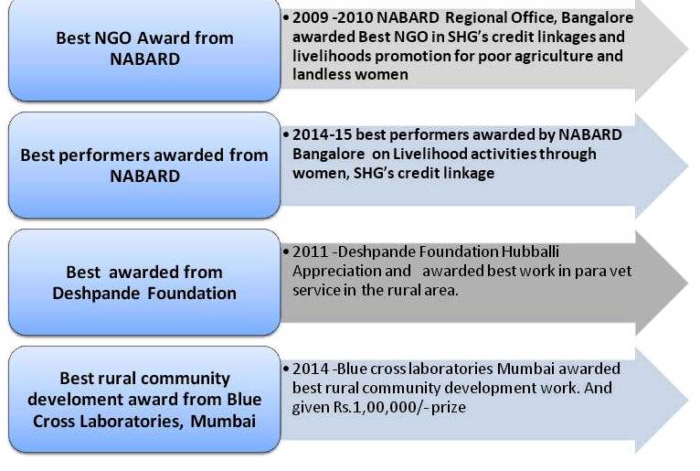

Funding and Guiding Partners of VRDS during 2022-23
1)
5)
4)
3)
2)

ANNUAL PROGRESS REPORT- 2022-23

VRDS progress performed during the year 2022-23 is as follows

- Labors and Small & Marginal farmers improved their living situation through their self-sustained community based organizations and their networks Project:

VRDS is continued the support of Andheri Hilfe for the project “Labors and Small & Marginal farmers improved their living situation through their self-sustained community based organizations and their networks”.The goal set for this project is sustainable development of 5,000 landless labors, small and marginal families through their local community based organizations and its networks by the end of project period.

The major highlightsof the project during the year is-

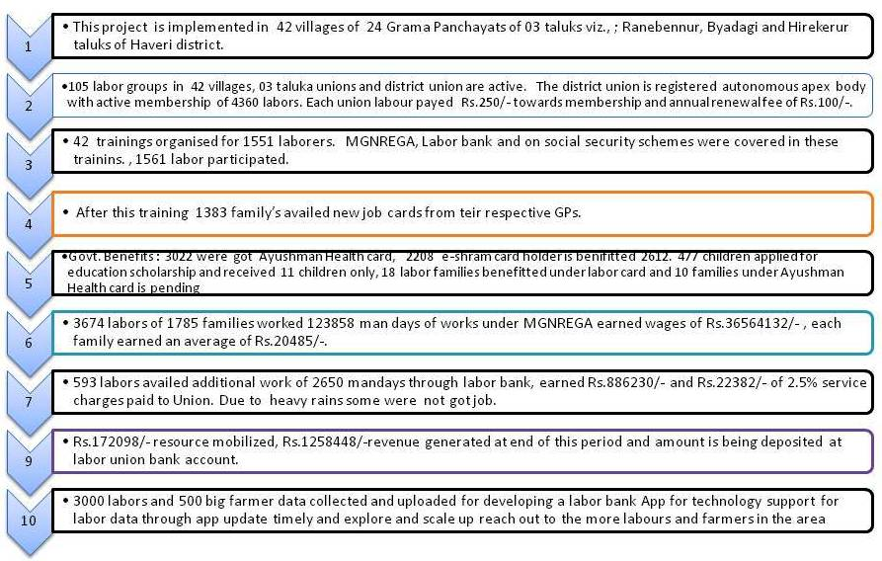
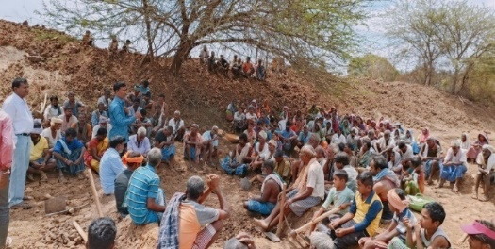 | 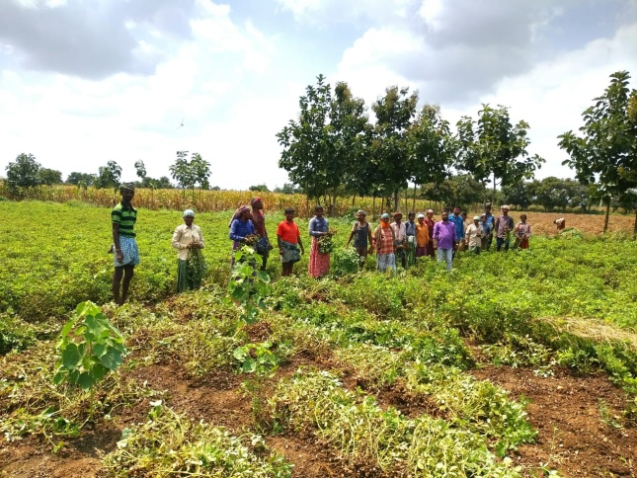 | 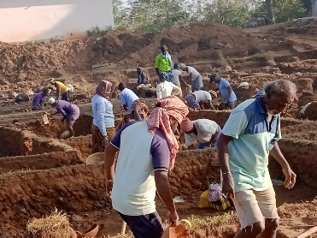

Training, meeting and capacity development :
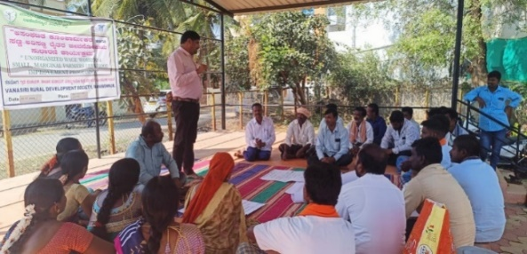
- 02 training conducted for labor union committee members on the issues of staff and selected volunteers on management of labor bank and resource mobilisation etc,
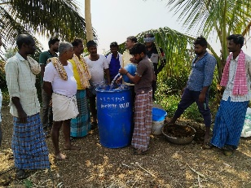
- 03 taluka union and district union regular meetings conducted, .
- The Labour bank collected Rs.172098/- and facilitated to get Rs.1258448/-revenue during the year. The amount deposited in the Bank account.

Farmers Welfare under MGNREGS and other linkages :
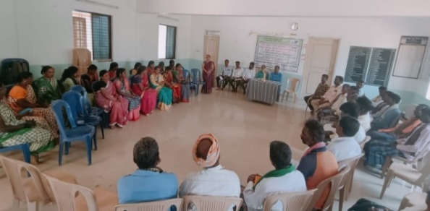
- 1705 farmers involved in 68 Interested Farmers groups are functioning in project area. They have structure, book keeping, regular meetings.
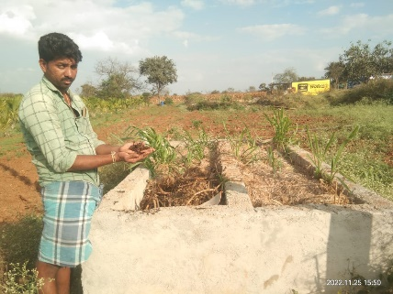
- 25 different types of farmers training conducted on agriculture. Total 771 farmers participated in those trainings.
- After the training 301 farmer’s land development plan prepared and included GPs action plan. 209 farmers adapted integrated/organic farming practices.
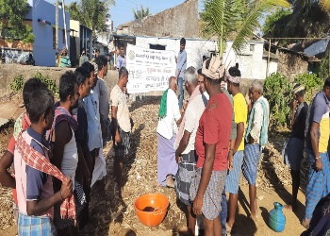
- 255 demonstration up in 42 villages, on 43 Jeevamrutha, 52 vermicompost, 52 fodder development plots, vegetable plots/ kitchen garden, 81 and chicks supported for back yard poultry to 27 women from Ah&VS Byadagi.
- 02 FPOs are functioning in the project area, FPOs have established 1104 farmer shareholders mobilised share capital of Rs.1237200/-,.Machinery Hire Centre and millets processing unit. FIGs member taken advantages of FPO services like agri inputs supply, tractor and equipment’s services on hire basis, value addition and marketing services etc. The business turnover done during the year about Rs.50-60 lakhs. The FPO has . Rs.32.00 lakhs assets and managed themselves.

- CIF-Jala Nela Watershed Project:

VRDS is being implemented the Jala Nela Watershed project inHaveri district. The project is continued in the 4th year with the support of The Concern India Foundation, Bangalore. The total Geographical area of the watershed is 1369.15 hectares of Hanumapura, Hanumapur Tanda in Ranebennur taluka and Chatra and Chatra Tanda villages in Byadgi taluka. The area is under rain fed condition covered 1039 families, among 80-90% of the families are small and marginal and landless agriculture labourers. The community mobilisation through the formation of 10 area groups, watershed development committee and 33 self-help groups in these villages for community participation in watershed development process. The major activities carried out is the community development and watershed area treatment activities through participatory approaches. This is an extended period of the project for fallow up of activities and to rebuild the damaged structure due to heavy rain fall of 3-4 months in the last monsoon and to promoted different agriculture practices, organic farming / integrated farming, entrepreneurship development and alternate livelihood IGA for landless and poor families in the watershed area.

Watershed area treatment
The watershed area treated mainly soil and water conservation through the Farm bunds (TCB) in the farmer fields across the slope is 32000 CMT, 324 waste weirs constructed in the farmer fields, 300 kg stylo hemata fodder seeds sowing on bunds to strengthen, 2 farm ponds, 3 bore well recharged and diversion channels. The drainage lines treated with construction of 180 mtr boulder bunds, 1RRS, 03 existing check dams was repaired. 19000 forest saplings of Teak, Meliea Dubiea, Silver Oak, Amla and Badami etc, and 7350 horticulture fruit pants of coconut, mango, guava, chikku, papaya and drumstick and cari laef etc in farmer fields. The different agriculture practices like mixed crops, poly crops, organic and integrated farming practices adopted by the farmers in the watershed area.
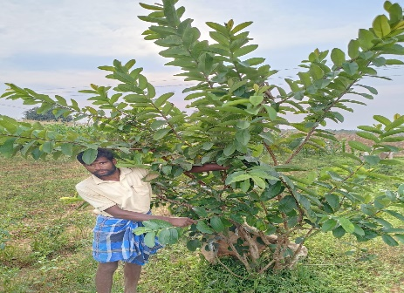
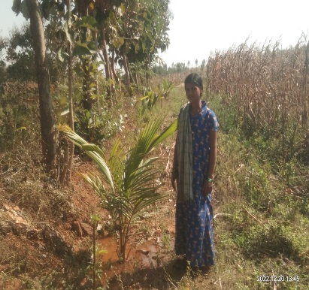
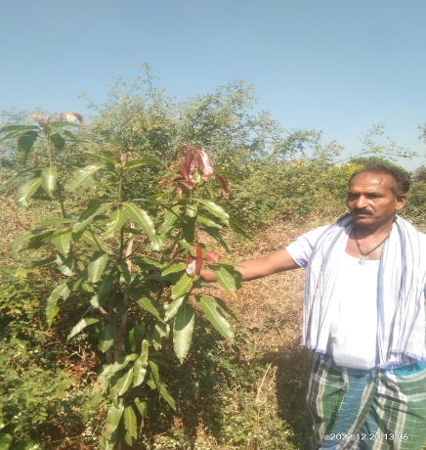
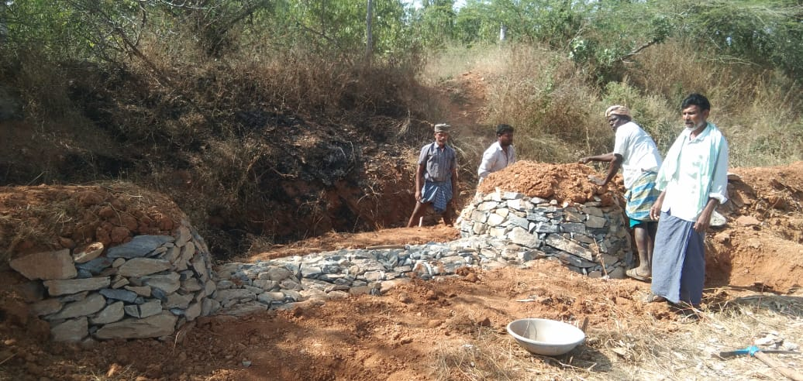
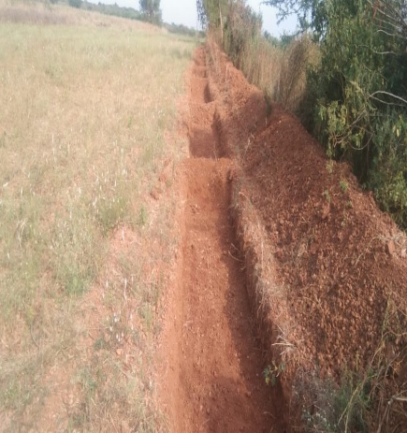
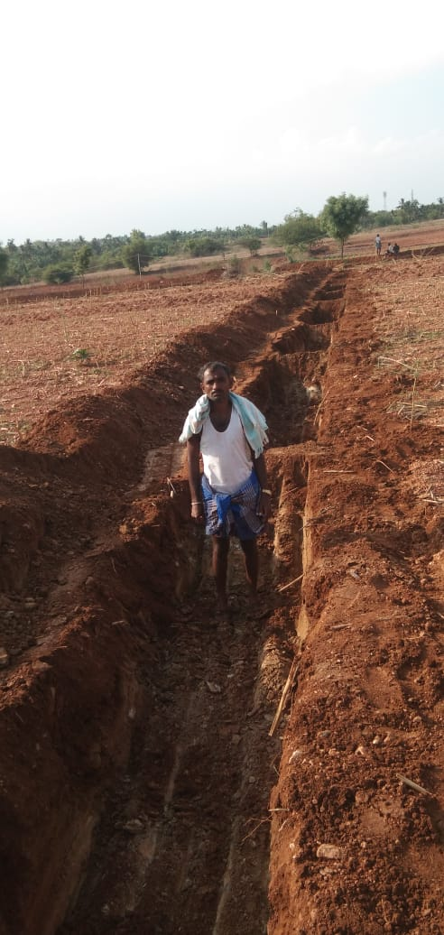
The fallow up of activities during the year is that most of the TCBs are filled with silts, damaged the bund and waste weirs in farmer fields and structures in the drainage line in the watershed area. Informed farmers about the importance of silt, after this de-silted 2800 CMT from the TCBs by farmers, 150 damaged waste weirs repaired, Check dam and RRS structure was repaired, de-silted the soil in drainage line and jungle clearance by the farmers. This will increased the water storage capacity in the rainy season that more infiltration of water will increase the ground water table.
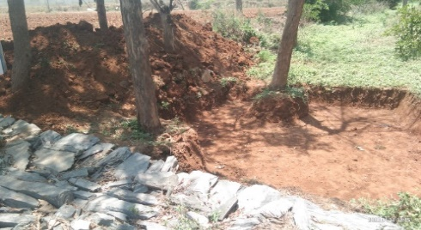
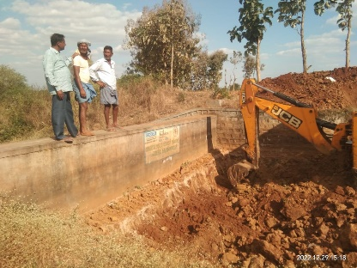
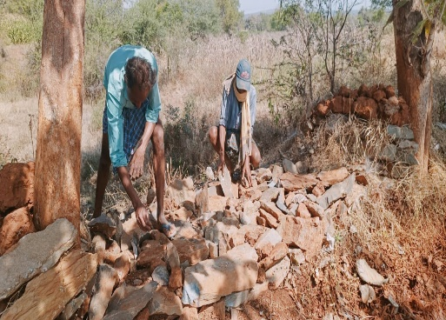
Apart from this 124 farmers those completed the land development activities have been planted 1200 horticulture fruit plants like coconut, guava and chikku in their lands. After care was taken by the farmers. The existing horticulture fruit plants like Guava, Chikku and papaya started baring the fruits and are being used themselves.

Community Development
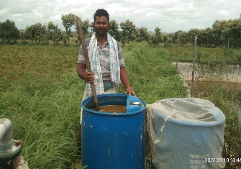
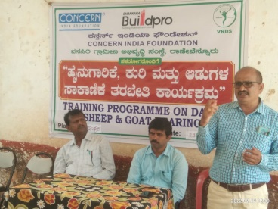
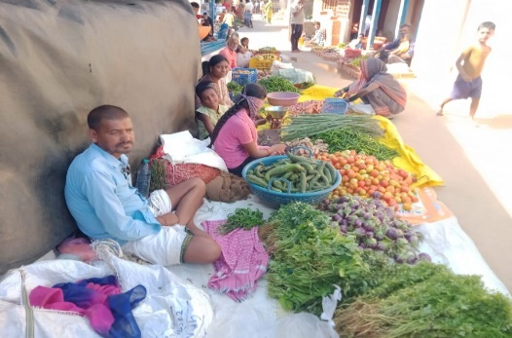
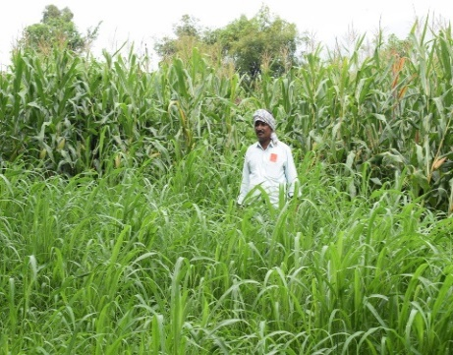
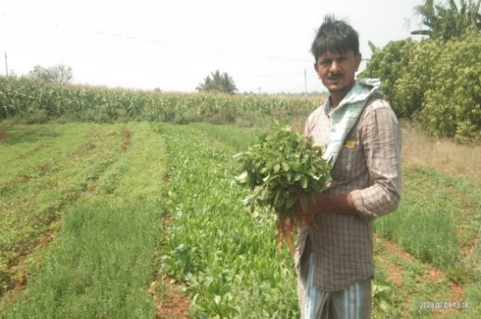
The formation and strengthening of existing community based organizations are playing an important role in community based watershed development approaches. Since inception of the project various community development activities is being done for the wellbeing of community as whole and individual like animal health camp, travice installation, various trainings, support of livelihood activities, tailoring and fashion designing under skill development, vermicomposting, demonstration of Jeevamritha preparation, Apart from this during covid 19 lockdown period, ration kits, health kits, working tools and fertilizer and seeds support to the poor families and small and marginal farmers in the watershed area.
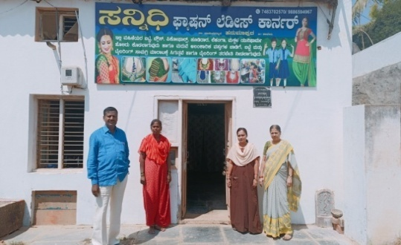
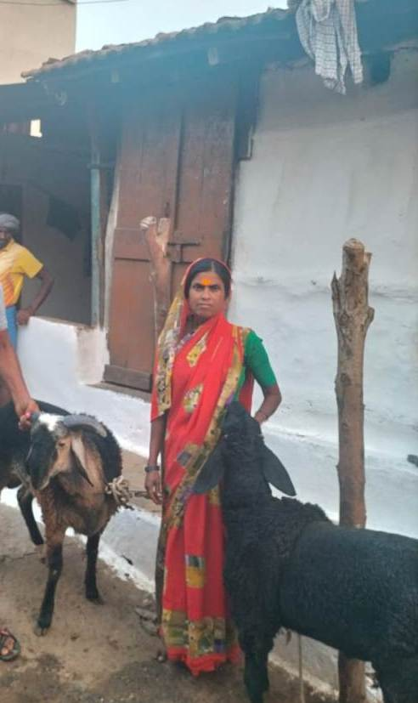
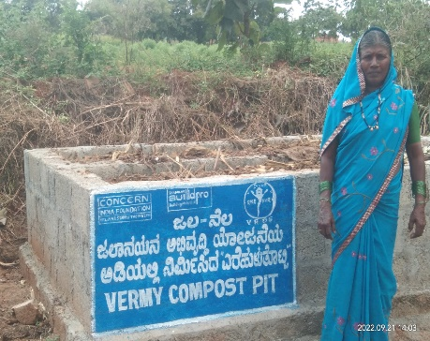
The community development activities is being implemented during this period is demonstration of 20 vermicomposting and 24 Jeevamrutha preparation , 25 Millets demo plots in farmers field and 50 kitchen gardens developed in the watershed area. Under the livelihood promotion 34 poor families supported IGA, 02 training conducted on livestock and established one tailoring shop and puchimaddu bio pesticide unit by trained SHG women.

Impact
The watershed development activities have been made significant positive results in the watershed area and community in the village.
- Soil erosion was reduced, increased moisture and soil fertility, diversified crops with better crops yields.
- The ground water table was increased, more water output in bore wells increased the cultivable area in Rabi season.
- The vegetative green coverage noticeably increased in watershed area, survival rate of forestry and horticulture fruit plants is 70-80 % and fruit plants started baring the fruits and are being used themselves.
- The cattle population increased due to plenty of fodder available in area results in more milk production in the villages.
- 15 SHG members are employed at garments factory wages earned Rs.7000-9000/- after the skill development training on tailoring and Fashion Designing, and rest of them self-employed at home earned wages of Rs.3000-4000/- per month.
- The economic status improved in destitute, poor women headed, landless and marginal families after involved in the livelihood activities in the villages earned income of Rs.3000-4000/- month.
- The farmers are adopted organic farming / integrated farming slowly by producing the vermicomposting and jeevamrutha liquid manure and used as an alternate to fertiliser for their crops will reducing the cost of cultivation.
- The vegetables consumption was noticeably increased in families after supported Kitchen garden, family health status improved and no kids suffering by malnutrition.
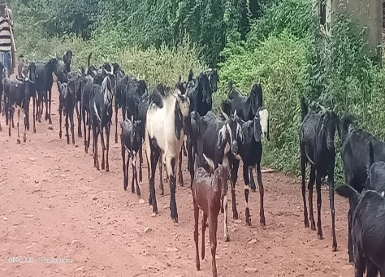

TDH- project (Education and livelihood promotion)
VRDS is being implemented the project “Education and livelihood promotion for covid-19 affected children and families in Ranebennur Taluka in Karnataka” will be implemented in 4 slums and 6 villages of Ranebennur Taluka.

The project aims to focus on promoting continued education for children among the target group, promote livelihood opportunities for covid19 affected single women headed families, youth empowerment through skill development, ensuring government social benefits and improving infrastructure in Government schools in the target areas.
- 16 awareness programme / events conducted in 04 slums in Ranebennur city and 06 project villages in rural area. 1757 children and stake holders participated such as teachers, SDMC members, PRI members, staff and parents.
- 10 Children Activity Centres (CAC) are functioning at 4 city slums and 6 project village. 30-40 children in each centre attended daily at 5.00 -7.00 pm from Monday to Saturday. The children are being educated in 10 CAC centres with tuition /special teaching activities by qualified teacher. 384 children are learning with interest at CAC centres.
The extra-curricular activities conducted for children are games and sports, singing and dance, drawing, quiz competition, moral storytelling, revision the school teachings and teach the tuition classes to the children learning behind.
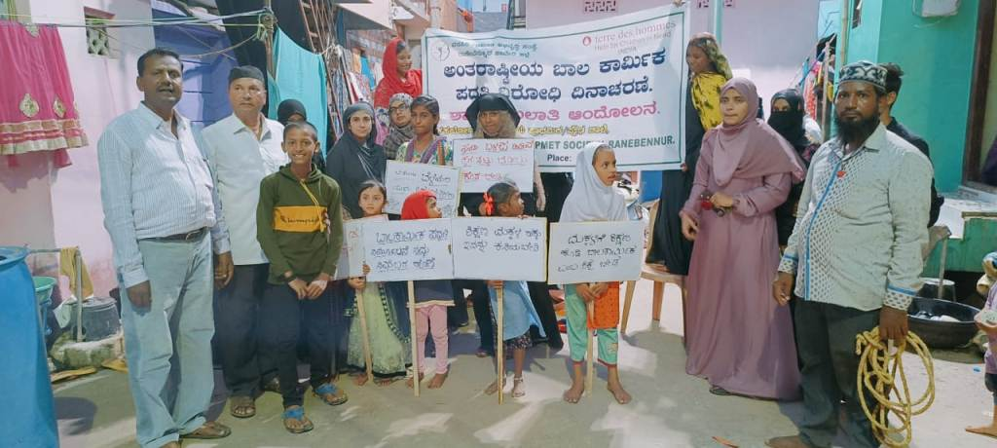
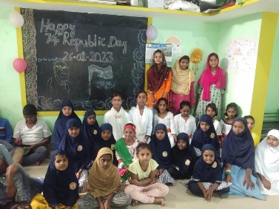
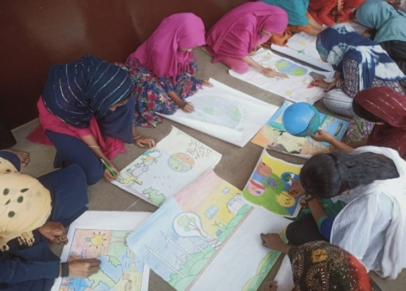
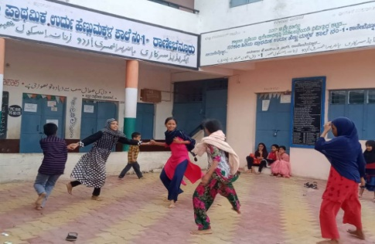
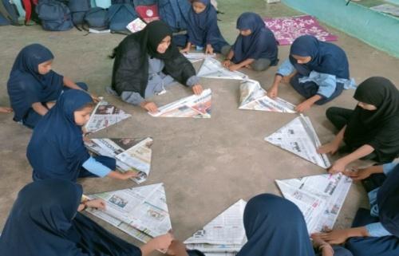
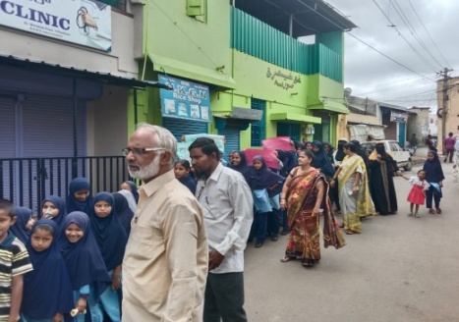
- Celebrated the national important days and festivals like Independence day, republic day, Gandhi jayanthi, Dr. Ambedkar Jayanthi, World Environmental Day and Earth day was celebrated in Children activity centre.

- The teachers training was conducted at Ranebennur, 10 teachers and staff participated and are aware of Children acts and rights like POCSO, JJ Act, SARRA & CARA Act, Bala vikasa samithi, Child marriage, Child labor, Child line, NEP, right to education, Gender sensitising, food security and malnutrition etc
- 11youth groups are functioning in project villages and slums, each group is consisting of 10-15 youths with total 202 youth members. They were conducting meeting once in a month and discuss the social issues and involved in social works for the development of village and slum area.
- 25 young women over the age of 18 years from poor families under gone 45 days skill development training on tailoring and fashion designing at city slum Ranebennur.
- 19 Young mothers/ pregnant women/ parents meetings were conducted in all CAC centres, 414 members participated, in these meetings trained on malnutrition, anaemia, obesity, and NRC, MNRC, ICDS programme.
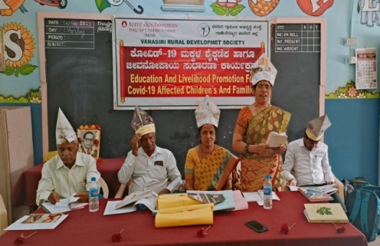
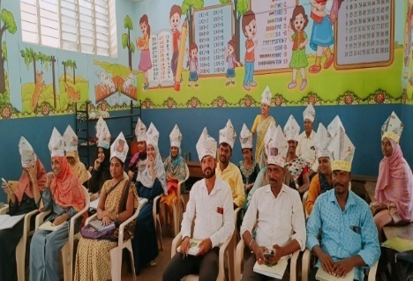
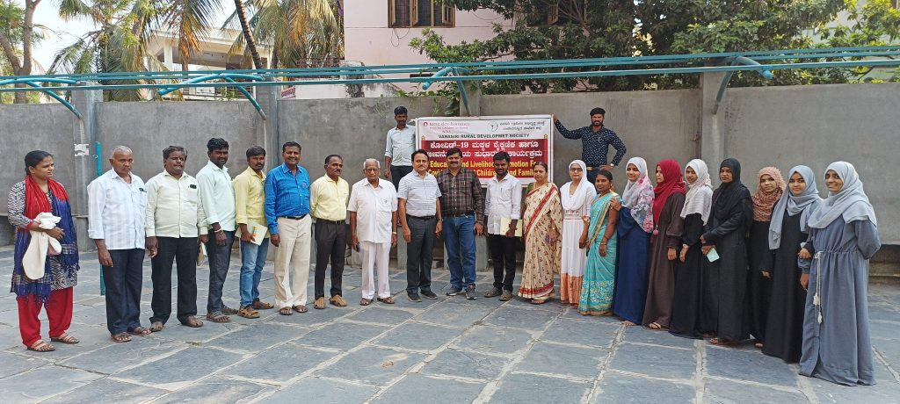

- The school audit has been conducted in all slums and project villages, many of schools needs toilet facility, play grounds and construction of compound walls and shortage of teachers etc. The VRDS has submitted memorandum to the CMC and concern grama panchayat for further action. The advocacy has been done by SDMC members and works have been included their action plan and it is in process.
- 523 labors of 16 labor groups from 05 project villages availed the work of 11386 man days under MGNREGA earned wages of Rs.30.99lakhs and labor bank provided work to 148 labors of 10 labor group availed the additional employment/ work of 1795 man days of work earned Rs.496800/- and Rs.12419.00 as 2.5% service charges paid by labor group to the labor bank account.
- Under the livelihood promotion, identified the 50 poor families and prioritising the poor women headed families those affected by COVID 19 and out of which 49 families get benefitted of Rs. 10000/-each and are get involved in income generating activities like rearing of sheep and goat, bangle vending, cloth business, vegetable vending, petty cash shops and tailoring etc.
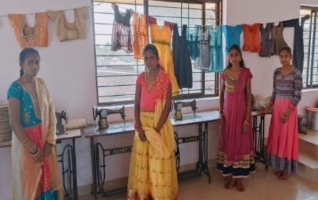
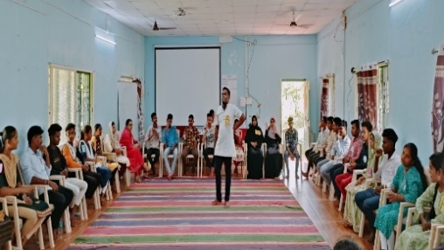

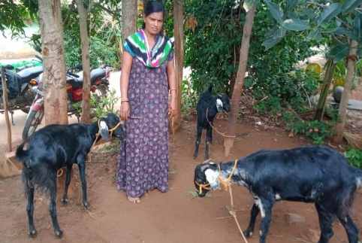
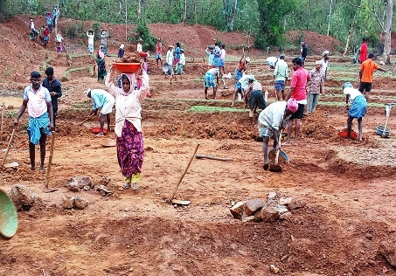
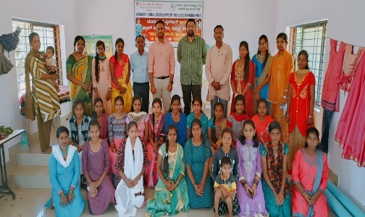

- Girl Child Project (Educational support for the Girl Child)
VRDS is being implemented the project Educational support for the Girl child with the support of The CIF - Concern India Foundation, Bangalore. The aim of this is to improve the educational status of child girl, sensitize the parents to continue their education, through the support increase the attendance and reduce dropouts.
- Identified the girl child from selected villages and slums those studying in 8-10std in high schools and 11-12std in PU colleges.
- Sensitising the parents in villages by conducting the door to door visits, situation analysed by discussing with parents.
- Parents meetings conducted in all selected villages and slums, child information data collected and selected 60 girl child for support and Information was collected about their performance of learning, family situation discussed with teachers by visiting all school/ college.
- Selected 45 girl child from 8th`-10th` class and 15 girl child from 11th`-12th` PU college for educational material and scholarship support Rs. 500/- for girl child of 8th`-10th` class and Rs.2000/-for girl child of 11th`-12th classes.
- The learning education material kit containing school bag, geometry box, uniform, shoes, note book, pen, pencil, ruled paper, exam pad, umbrella, Tiffin box, calculator and water bottle etc, and scholarship amount will transfer through DBT to their bank account.

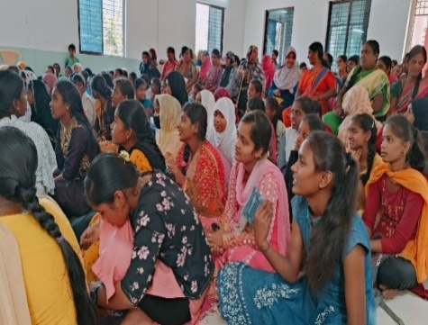
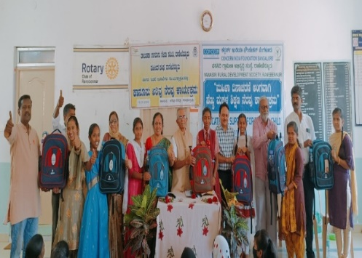
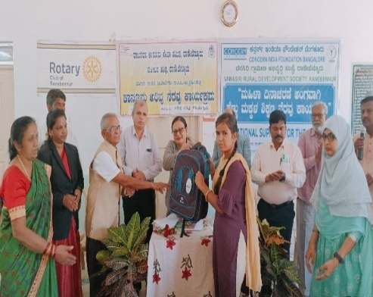
VRDS organised programme at Ranebennur for distribution of kits. The Judge, Civil court, Ranebennur, President, Rotary Club Ranebennur and president and executive Director of VRDS participated as chief guests. The senior lawyers, directors and staff of VRDS, parents and children are participated in this programme. The chief guests informed about the importance of girl child education, educating the girl child will enable her to realize her full potential, to think, question and judge independently, child rights, rights to education and on POCSO. The guest were distributed educational learning materials kits to 60 girl child on this accession.
VRDS is monitoring the attendance and academic performance of 60 girl child at their schools / colleges.

VRDS Recognised by

Awarded
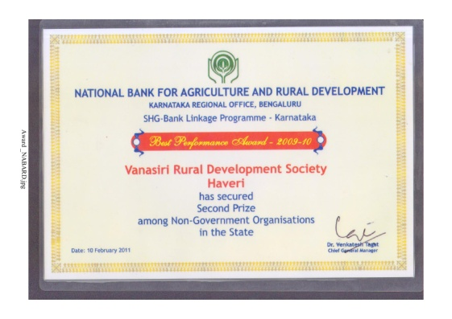  2009 -2010 NABARD Bangalore awarded best NGO in SHG’s credit linkages and livelihoods promotion for poor agriculture and landless women. |  | 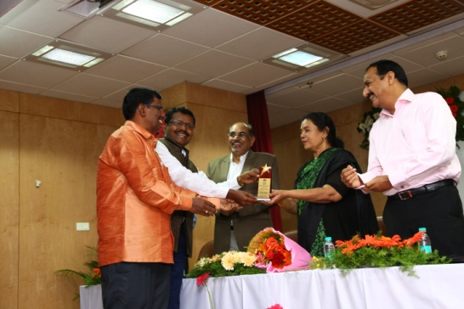  2014-15 best performers awarded by NABARD Bangalore on Livelihood activities through women, SHG’s credit linkage
Received Appreciation
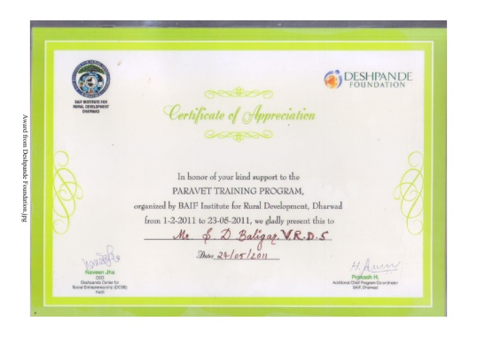  Deshpande Foundation Hubballi Appreciation and awarded best work in para vet service in the rural area. In 2011 | 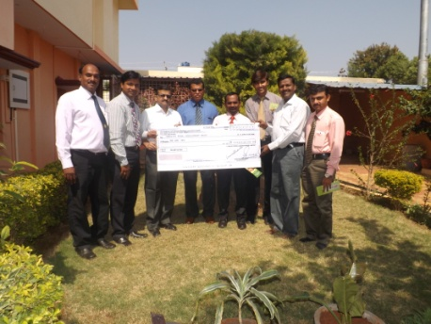  Blue cross laboratories Mumbai awarded best Rural community development work. Rs.1,00,000/- prize
our partners

- Andheri Hilfe Bonn Germany
- Terre Des Hommes Germany
- Concern India Foundation Bangalore
- NABARD Bangalore

Supporters
- Zilla panchayat Haveri
- Agriculture and Horticulture department Haveri
- Prakalpa soujanya Foundation Bangalore

